Appendix: Challenges in conducting fractional polynomial and standard parametric network meta-analyses of immune checkpoint inhibitors for first-line advanced renal cell carcinoma
Table of Contents
Appendix: Challenges in the time-varying hazard NMA of immune checkpoint inhibitors for first-line advanced renal cell carcinoma 1
1 Feasibility assessment 4
1.1 Heterogeneity assessment 4
1.1.1 Items assessed for heterogeneity between trials 4
1.1.2 Overview of relevant baseline characteristics across trials 5
1.2 Assessment of the proportional hazards (PH) assumption 6
1.2.1 Criteria applied 6
1.2.2 Results 7
1.3 Network of evidence 8
2 Non-proportional hazards NMA outcomes 9
2.1 Model fitting 9
2.2 Model selection algorithm: face validity check of first- and second-order models 11
2.2.1 Time-varying HR plots versus trial hazards second order polynomial for OS 11
2.3 Model selection algorithm: Predictive accuracy against trial data 22
2.3.1 PFS 23
2.3.2 OS 29
References 31

Table of abbreviations

CI Confidence interval
CrI Credible interval
DIC Deviance information criterion
GT Grambsch and Therneau
HR Hazard ratio
IMDC International Metastatic RCC Database Consortium
MSKCC Memorial Sloan Kettering Cancer Center score
NMA Network Meta Analysis
OS Overall Survival
PFS Progression free survival
PH Proportional hazards
RCC Renal cell carcinoma
SD Standard deviation
SUN Sunitinib

Feasibility assessment

Heterogeneity assessment

Items assessed for heterogeneity between trials
Table 1 PICOS items for similarity assessment
PICOS item | Evaluated information
Patient characteristics | - Age  - Sex  - ECOG-PS  - MSKCC score / IMDC score  - Prior nephrectomy  - Prior use of radiation therapy  - PD-L1 status  - Metastatic sites  - Number of metastatic sites  - Location of metastatic sites  - Race  - Region
Intervention | - Treatment dose and regimen
Comparator | - Treatment dose and regimen
Outcome definition | - Definition of PFS  - Stratified vs. unstratified results
Study characteristics | - Study phase  - Number of patients  - Study aim  - Study design (for example, cross-over design)  - Follow-up duration
ECOG-PS, Eastern Cooperative Oncology Group Performance Status; IMDC, International Metastatic RCC Database Consortium score; MSKCC, Memorial Sloan Kettering Cancer Center score

Overview of relevant baseline characteristics across trials
Study | Trial name | Treatment | Dose | Regimen | n | % ECOG 0 | % IMDC score  Favorable | % IMDC score  Intermediate | % IMDC score  Poor | % Prior nephric-tomy | % Prior radiation therapy | % PD-L1 expression ≥ 1% cut-off | % ≥2 metastatic sites
Choueiri 2021[1] | CheckMate 9ER | NIV+CAB | NIV: 240 mg  CAB: 40 mg | Every 2 weeks  Once daily | 323 | 80 | 23 | 58 | 19 | 69 | 14 | 25 | 81
Choueiri 2021[1] | CheckMate 9ER | SUN | 50 mg | 6-week cycle: once daily (4wk) + no treatment (2wk) | 328 | 74 | 22 | 57 | 21 | 71 | 14 | 25 | 78
Motzer 2019[2] | JAVELIN Renal 101 | AVE+AXI | AVE: 10mg/kg  AXI: 5 mg | Every 2 weeks  Twice daily | 442 | 63 | 21 | 61 | 16 | 80 | NR | 61 | NR
Motzer 2019[2] | JAVELIN Renal 101 | SUN | 50 mg | 6-week cycle: once daily (4wk) + no treatment (2wk) | 444 | 63 | 22 | 62 | 16 | 80 | NR | 65 | NR
Rini 2019[3] | KEYNOTE-426 | PEM+AXI | PEM: 200 mg  AXI: 5 mg | Every 3 weeks  Every 2 days | 432 | NR | 32 | 55 | 13 | 83 | 10 | 56 | 73
Rini 2019[3] | KEYNOTE-426 | SUN | 50 mg | 6-week cycle: once daily (4wk) + no treatment (2wk) | 429 | NR | 30 | 57 | 12 | 83 | 9 | 59 | 77
Motzer 2021[4]  CLEAR | CLEAR | PEM+LEN | PEM: 200 mg  LEN: 20 mg | 3-week cycle: once daily  Every 3 weeks | 355 | NR | 31 | 59 | 9 | 74 | NR | 30 | 72
Motzer 2021[4]  CLEAR | CLEAR | SUN | 50 mg | 6-week cycle: once daily (4wk) + no treatment (2wk) | 357 | NR | 35 | 54 | 10 | 77 | NR | 33 | 69

Assessment of the proportional hazards (PH) assumption

Criteria applied
- Log-cumulative hazard plots
  - A hazard plot of the log (cumulative hazard) against log (time (months)) is used to assess proportionality of hazards of progression/mortality over
  - Crossing of hazards in the plot can indicate that the proportional hazards assumption may be violated, however also a marked divergence from the parallel can indicate that the PH does not hold
- Schoenfeld residuals test
  - Testing for time-dependency of the hazard ratio (HR) is equivalent to testing for a non-zero slope in a generalized linear regression of the scaled Schoenfeld residuals over time
  - A non-zero slope or the log (HR) not falling within the 95% confidence interval (CI) bands indicates a potential violation of the PH assumption
- Grambsch and Therneau (GT) test
  - Assesses whether the slope in a generalized linear regression of the scaled Schoenfeld residuals over time is zero
  - If the p-value is significant (<0.05), it can be viewed as a potential violation of the PH assumption
- Decision criteria
  - When the 2 visual inspection plots provided conflicting results, the final decision on whether the PH assumption was violated was based upon the result of the GT test
  - If a significant number of trials within the networks of evidence violated the PH assumption, a non-proportional hazards NMA was recommended as an alternative approach

Results
Table 2. Results from testing the PH assumption
Study | Trial | Treatment | Grambsch Therneau test (violation [p-value]) | Schoenfeld residuals test (Non-zero slope) | Log-cumulative hazard plots (Crossing curves) | Violates PH assumptionª
 |  |  | Violation of PH assumption for PFS
IPD | CheckMate 9ER  (DBL July 2021) | NIV+CAB | Yes [0.027] | Yes | Yes | Yes
IPD | CheckMate 9ER  (DBL July 2021) | SUN
Choueiri  2020[5] | JAVELIN Renal 101 | AVE+AXI | No [0.931] | No | Yes | No
Choueiri  2020[5] | JAVELIN Renal 101 | SUN
Rini 2021[6] | KEYNOTE-426 | PEM+AXI | No [0.892] | No | No | No
Rini 2021[6] | KEYNOTE-426 | SUN
Motzer 2021[4] | CLEAR | SUN | Yes [0.047] | Yes | Yes | Yes
Motzer 2021[4] | CLEAR | PEM+LEN
 |  |  | Violation of PH assumption for OS
IPD | CheckMate 9ER  (DBL July 2021) | NIV+CAB | Yes [0.016] | Yes | Yes | Yes
IPD | CheckMate 9ER  (DBL July 2021) | SUN
Choueiri  2020[5] | JAVELIN Renal 101 | AVE+AXI | No [0.4216] | No | Yes | No
Choueiri  2020[5] | JAVELIN Renal 101 | SUN
Rini 2021[6] | KEYNOTE-426 | PEM+AXI | Yes [0.0270] | Yes | Yes | Yes
Rini 2021[6] | KEYNOTE-426 | SUN
Motzer 2021[4] | CLEAR | SUN | Yes [0.0012] | Yes | Yes | Yes
Motzer 2021[4] | CLEAR | PEM+LEN
ª Decision was made on violation in 2 of the 3 tests.

Network of evidence
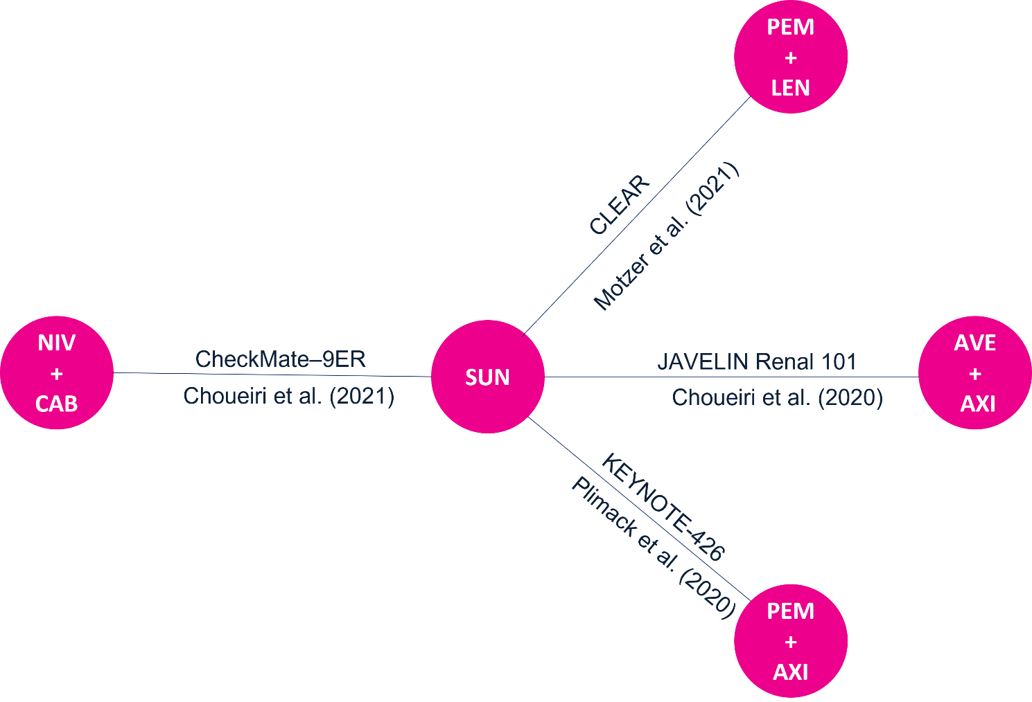
Figure 1: Network of evidence for OS and PFS

A
B
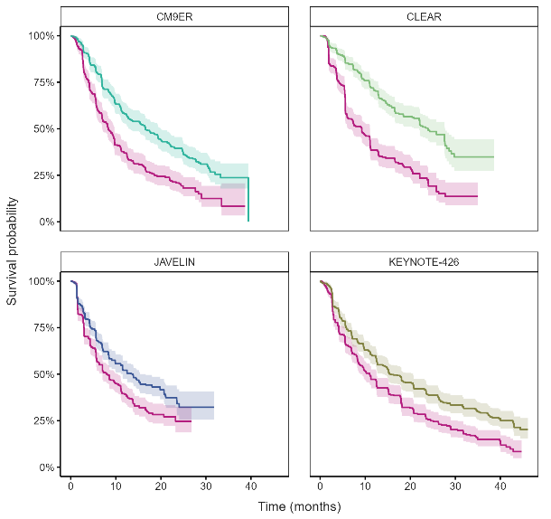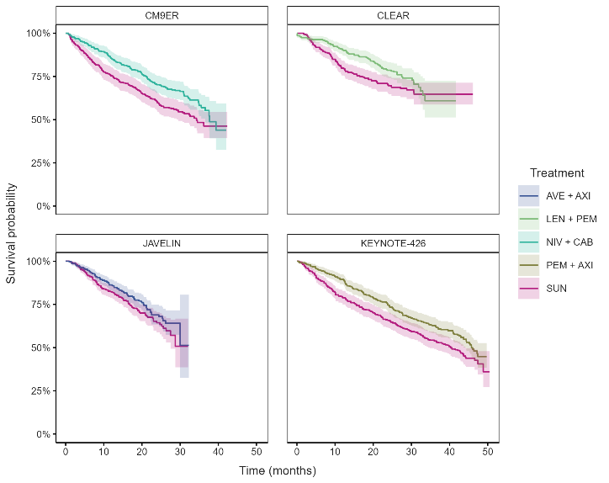
Figure 2. Input data based on (pseudo)-IPD for (A) PFS and for (B) OS

Non-proportional hazards NMA outcomes

Model fitting
The analysis was conducted in R and executed using the software package Stan[7] using four chains with N=3500 iterations per chain of which N=1750 were used for burn-in.

Table 3. DIC model fits
Model | OS | PFS
FP(-2) (fixed effects) | 228.5539 | 361.5619
FP(-2,-2) (fixed effects) | 222.5972 | 268.6800
FP(-2,-1) (fixed effects) | 215.1445 | 268.7387
FP(-2,-0.5) (fixed effects) | 207.5568 | 274.1631
FP(-2,0) (fixed effects) | 205.0474 | 283.6895
FP(-2,0.5) (fixed effects) | 202.6927 | 296.9649
FP(-2,1) (fixed effects) | 201.8812 | 310.9834
FP(-2,2) (fixed effects) | Not converging | 337.3401
FP(-1) (fixed effects) | 227.7378 | 377.6337
FP(-1,-1) (fixed effects) | 207.1239 | 278.3008
FP(-1,-0.5) (fixed effects) | 211.3478 | 286.6596
FP(-1,0) (fixed effects) | 206.3537 | 301.3737
FP(-1,0.5) (fixed effects) | 206.1599 | 316.9097
FP(-1,1) (fixed effects) | 207.0309 | 333.3391
FP(-1,2) (fixed effects) | Not converging | 359.5024
FP(-0.5) (fixed effects) | 225.4133 | 380.6506
FP(-0.5,-0.5) (fixed effects) | 207.3684 | 299.8550
FP(-0.5,0) (fixed effects) | 209.3095 | 313.3352
FP(-0.5,0.5) (fixed effects) | 208.9233 | 331.1895
FP(-0.5,1) (fixed effects) | 209.7561 | 347.0343
FP(-0.5,2) (fixed effects) | Not converging | 370.3001
FP(0) (fixed effects) | 222.0661 | 378.0990
FP(0,0) (fixed effects) | 209.8433 | 330.7859
FP(0,0.5) (fixed effects) | 211.6640 | 346.4398
FP(0,1) (fixed effects) | 212.9932 | 360.8262
FP(0,2) (fixed effects) | Not converging | 379.8799
FP(0.5) (fixed effects) | 218.5230 | 373.2221
FP(0.5,0.5) (fixed effects) | 213.4884 | 360.5627
FP(0.5,1) (fixed effects) | 215.6279 | 371.6328
FP(0.5,2) (fixed effects) | Not converging | 383.8631
FP(1) (fixed effects) | 216.3228 | 371.2471
FP(1,1) (fixed effects) | 216.9066 | 378.6368
FP(1,2) (fixed effects) | Not converging | 382.3083
FP(2) (fixed effects) | Not converging | 376.2310
FP(2,2) (fixed effects) | Not converging | 375.3668
loglogistic (fixed effects) | 230.9017 | 336.3549
lognormal (fixed effects) | 242.3480 | 321.1411

Table 4. Non-converging models
 | OS |  | PFS
Model | DIC | Number of non-converging parameters (R-hat>1.2) | DIC | Number of non-converging parameters (R-hat>1.2)
FP(3) (fixed effects) | 65786.25 | 18 | 909.09 | 16
FP(3,-2) (fixed effects) | 59428.00 | 28 | 897.49 | 25
FP(3,-1) (fixed effects) | 62234.62 | 26 | 898.36 | 30
FP(3,-0.5) (fixed effects) | 69639.78 | 30 | 949.32 | 28
FP(3,0) (fixed effects) | 691520.37 | 35 | 7441.60 | 32
FP(3,0.5) (fixed effects) | 474928.90 | 33 | 7900.32 | 36
FP(3,1) (fixed effects) | 460183.94 | 35 | 7343.99 | 37
FP(3,2) (fixed effects) | 126096.23 | 37 | 68024.78 | 28
FP(3,3) (fixed effects) | 34230.47 | 31 | 135178.02 | 31
FP(-0.5,2) (fixed effects) | 35445.65 | 22 | - | -
FP(-1,2) (fixed effects) | 35480.66 | 22 | - | -
FP(-2,2) (fixed effects) | 35479.88 | 22 | - | -
FP(0,2) (fixed effects) | 35376.40 | 22 | - | -
FP(0.5,2) (fixed effects) | 35327.19 | 23 | - | -
FP(1,2) (fixed effects) | 34781.28 | 24 | - | -
FP(2) (fixed effects) | 35485.48 | 14 | - | -
FP(2,2) (fixed effects) | 42859.41 | 24 | - | -

Model selection algorithm: face validity check of first- and second-order models

Time-varying HR plots versus trial hazards second order polynomial for OS
During the face validity check of the converging models, the second-order models for OS have been excluded as these showed extremely variable and implausible time-varying HRs, mostly for the PEM+LEN arm. Time-varying HR plots versus trial hazards after anchoring, for the excluded second-order OS models are shown in Figure 3 to Figure 23.

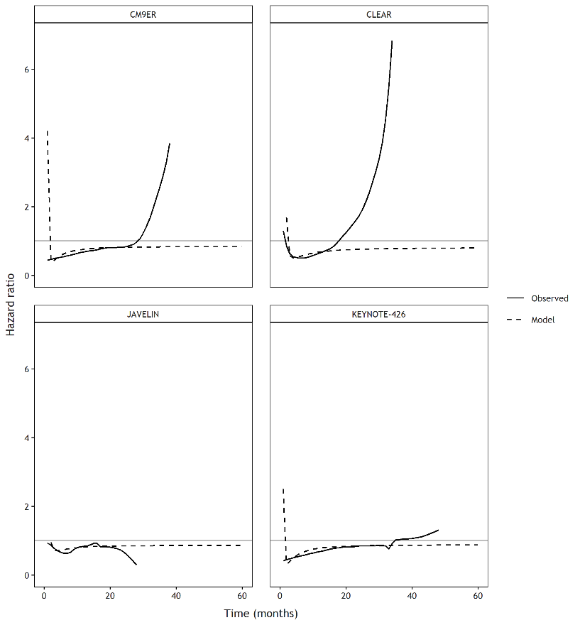
Figure 3: FP(-2,-2) (fixed effects).
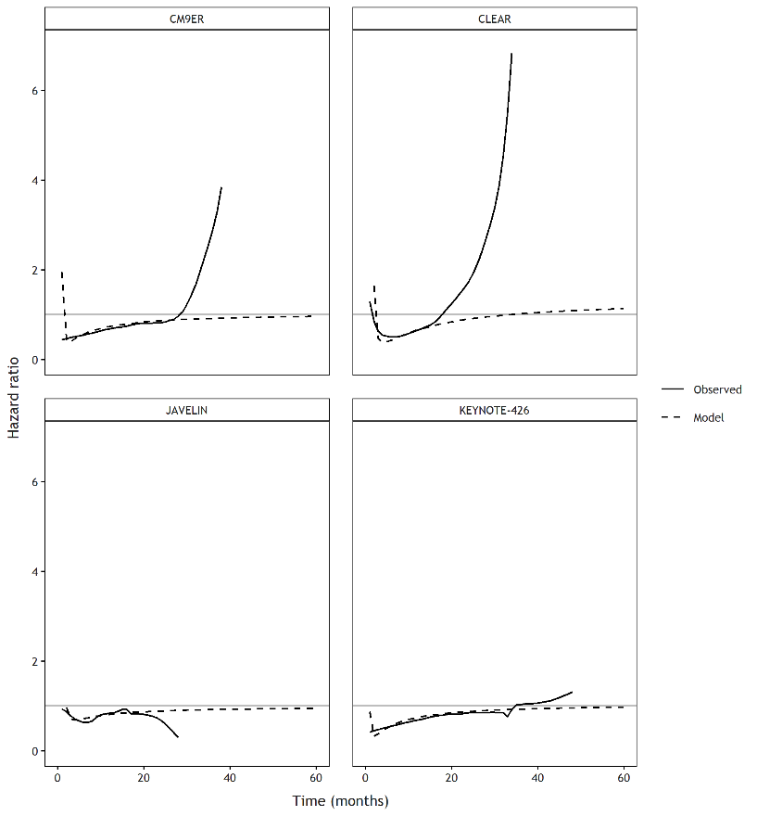
Figure 4: FP(-2,-1) (fixed effects).
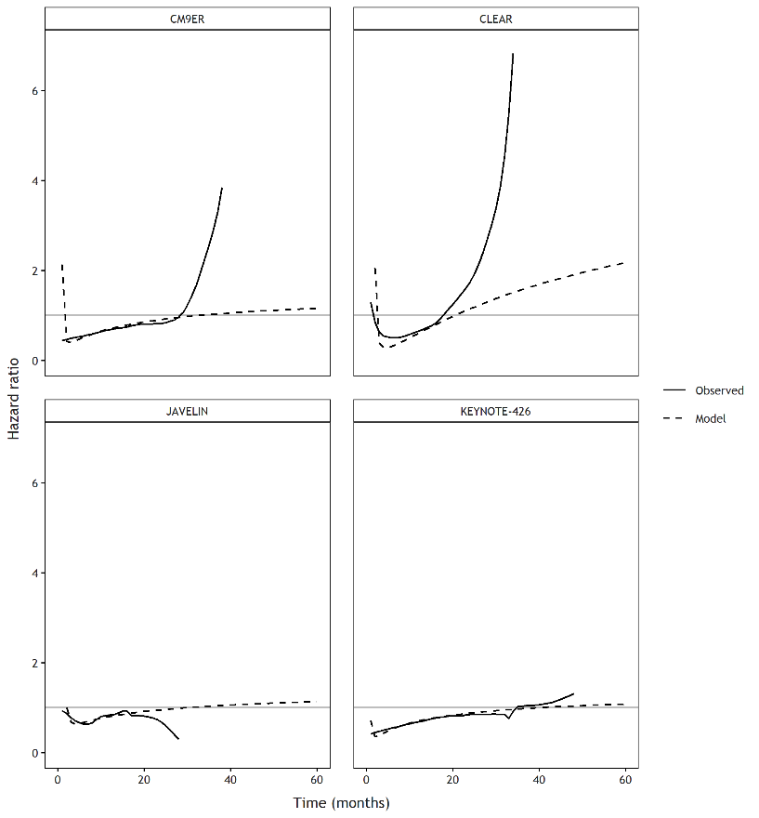
Figure 5: FP(-2,-0.5) (fixed effects).
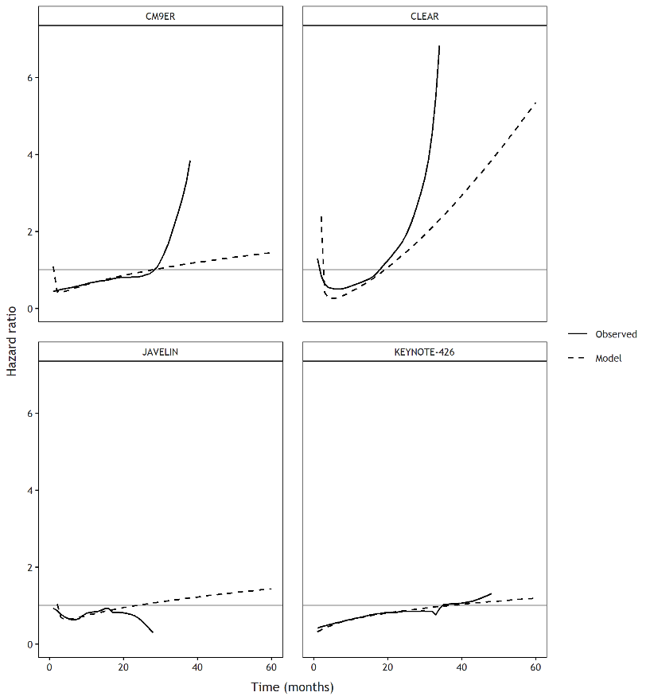
Figure 6: FP(-2,0) (fixed effects).
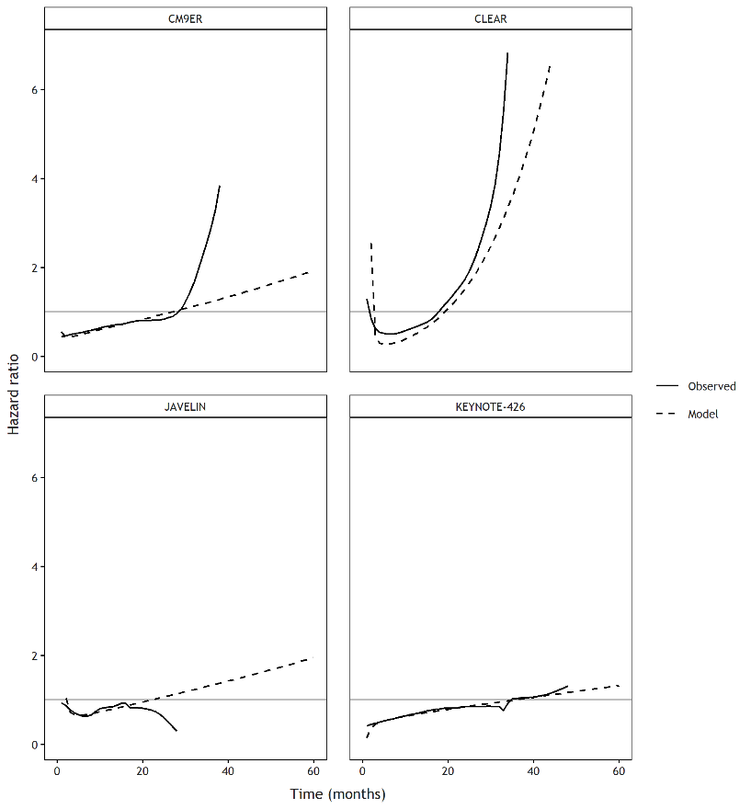
Figure 7: FP(-2,0.5) (fixed effects).
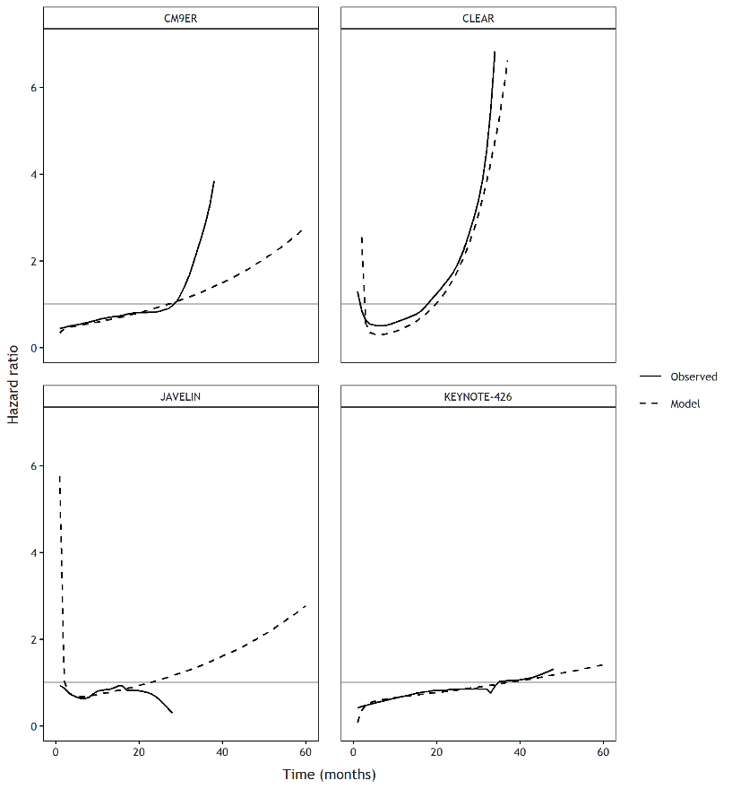
Figure 8: FP(-2,1) (fixed effects).
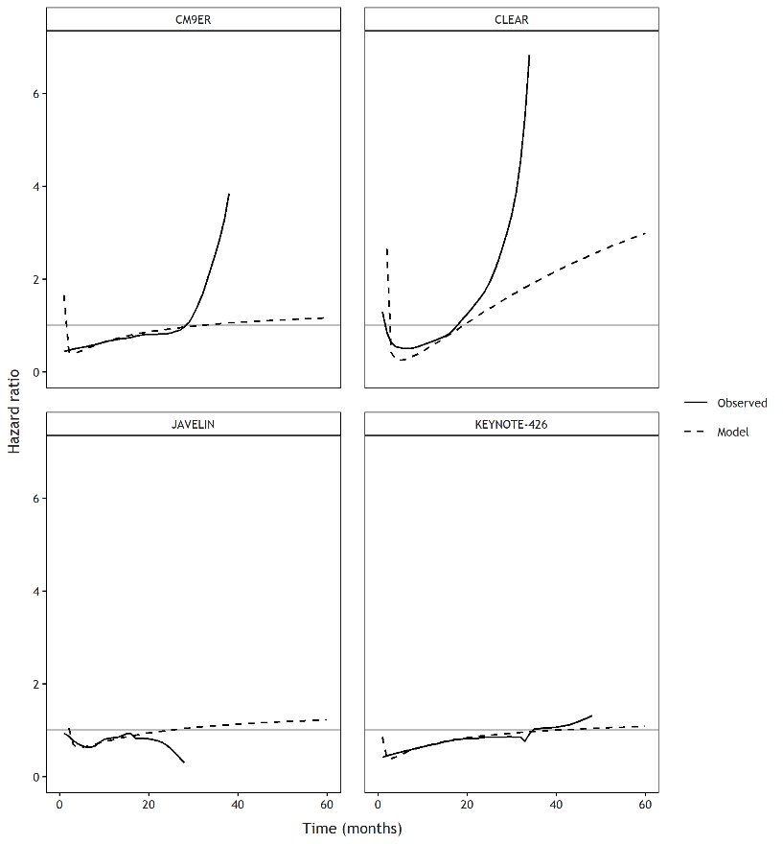
Figure 9: FP(-1,-1) (fixed effects).
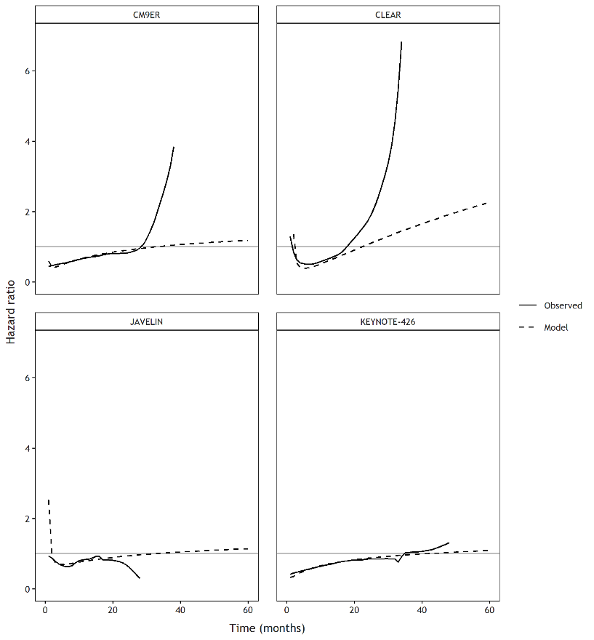
Figure 10: FP(-1,-0.5) (fixed effects).
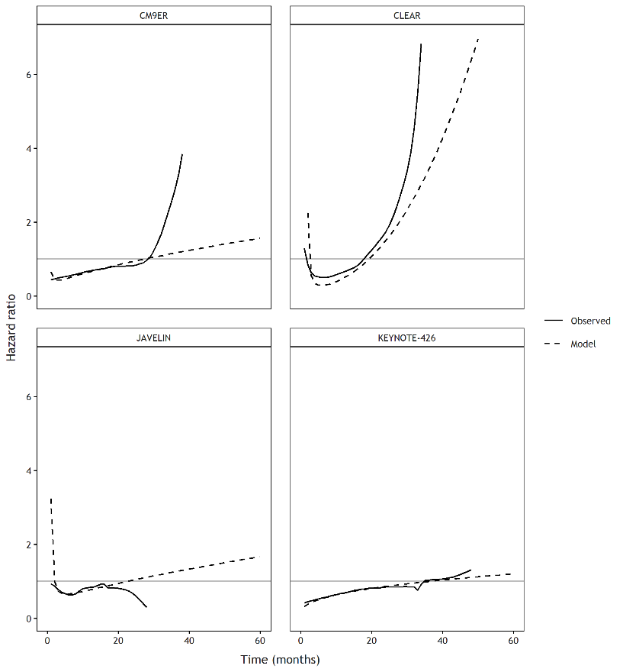
Figure 11: FP(-1,0) (fixed effects).
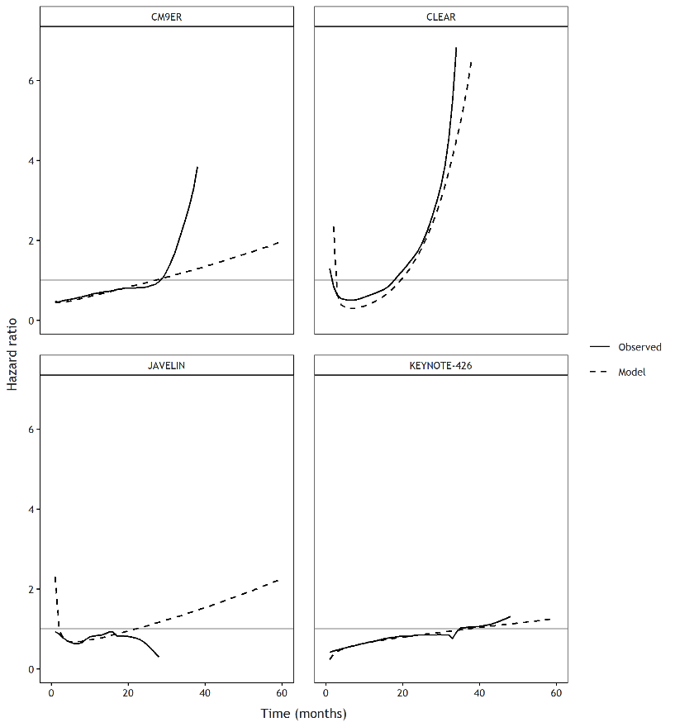
Figure 12: FP(-1,0.5) (fixed effects).
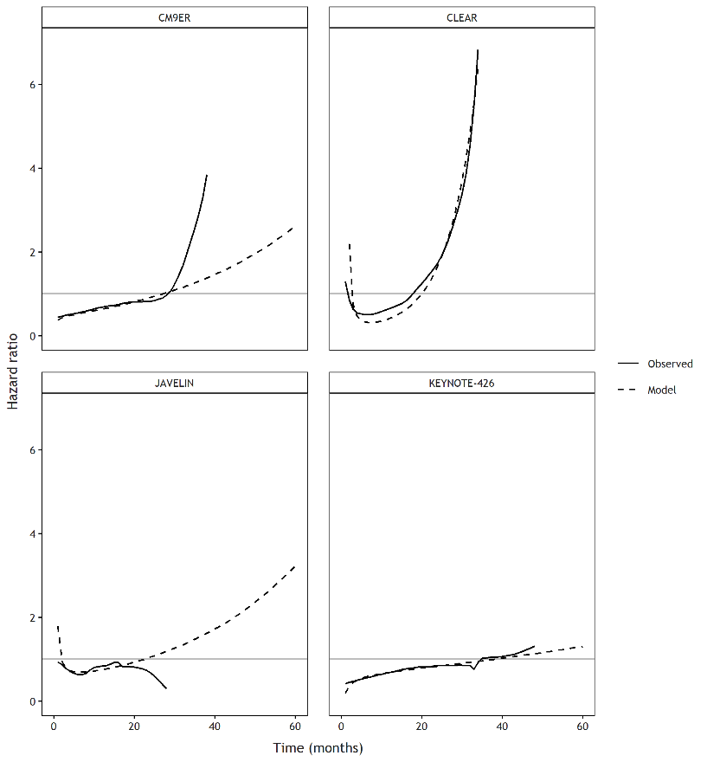
Figure 13: FP(-1,1) (fixed effects).
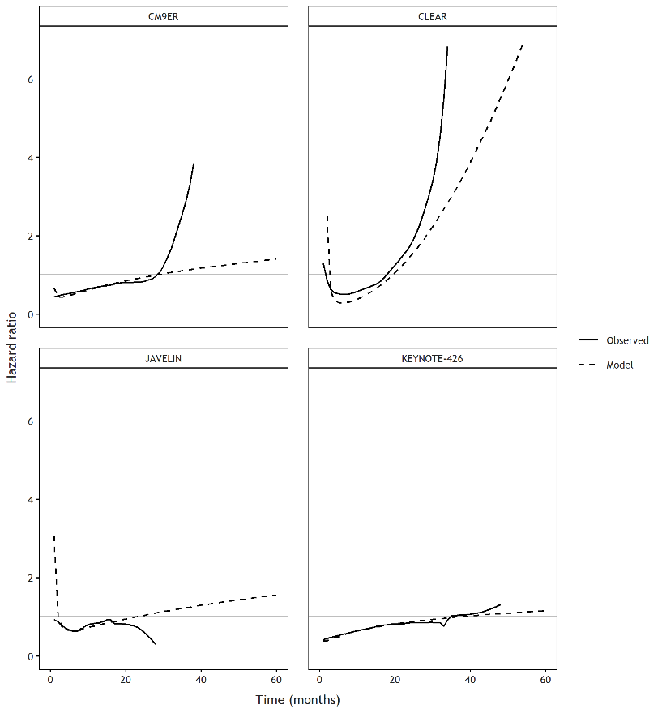
Figure 14: FP(-0.5,-0.5) (fixed effects).
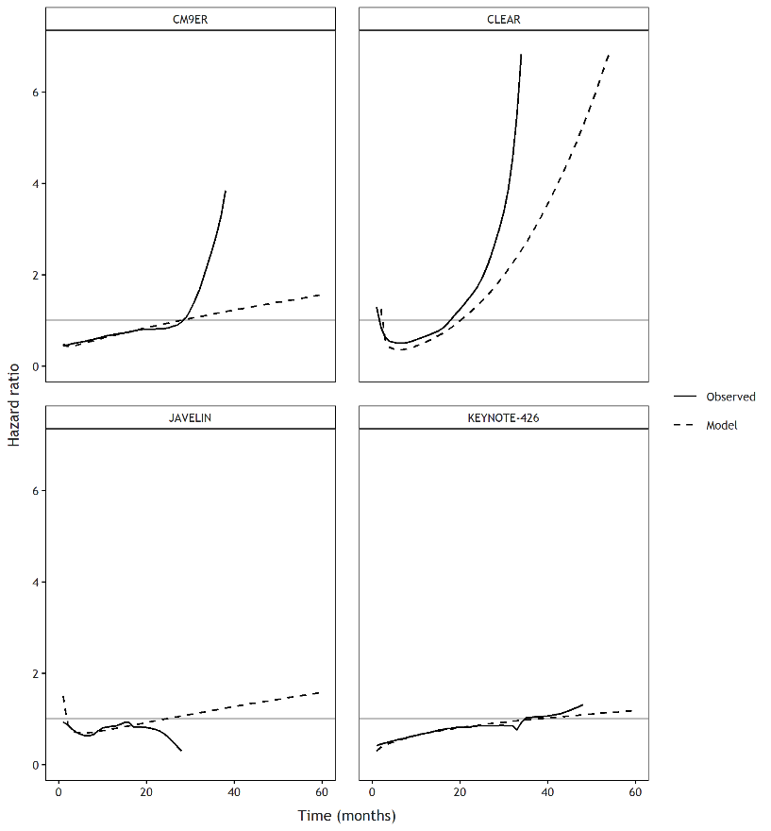
Figure 15: FP(-0.5,0) (fixed effects).
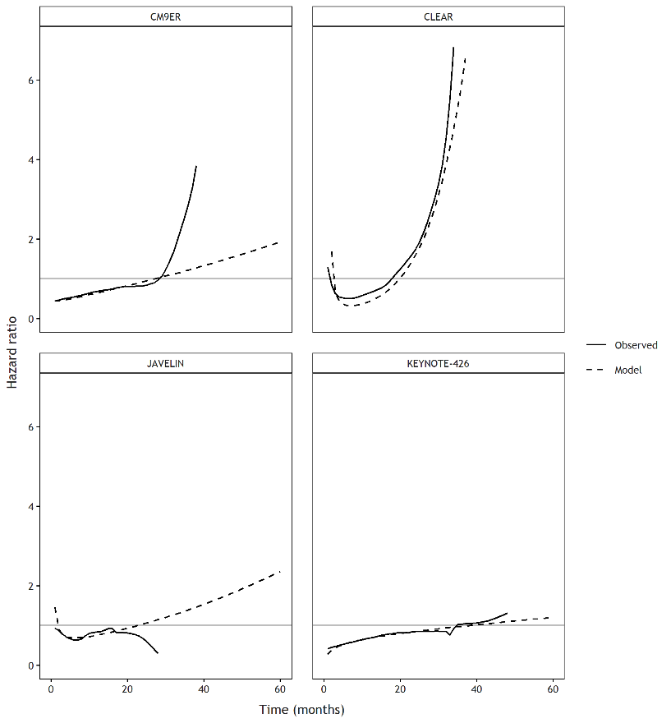
Figure 16: FP(-0.5,0.5) (fixed effects).
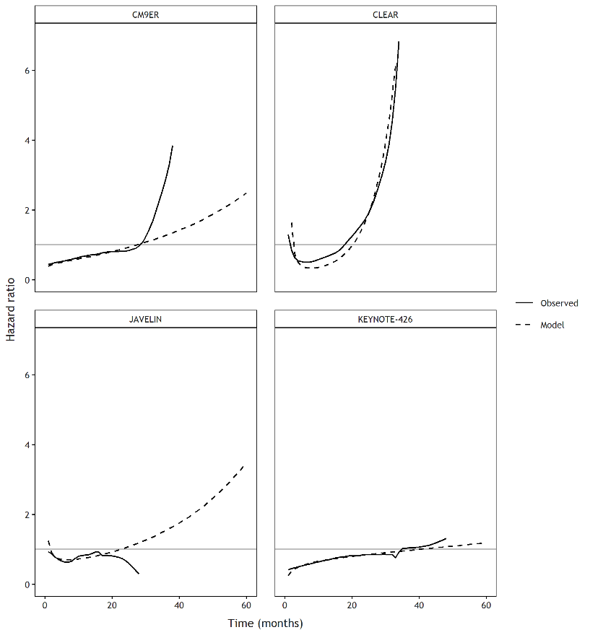
Figure 17: FP(-0.5,1) (fixed effects).
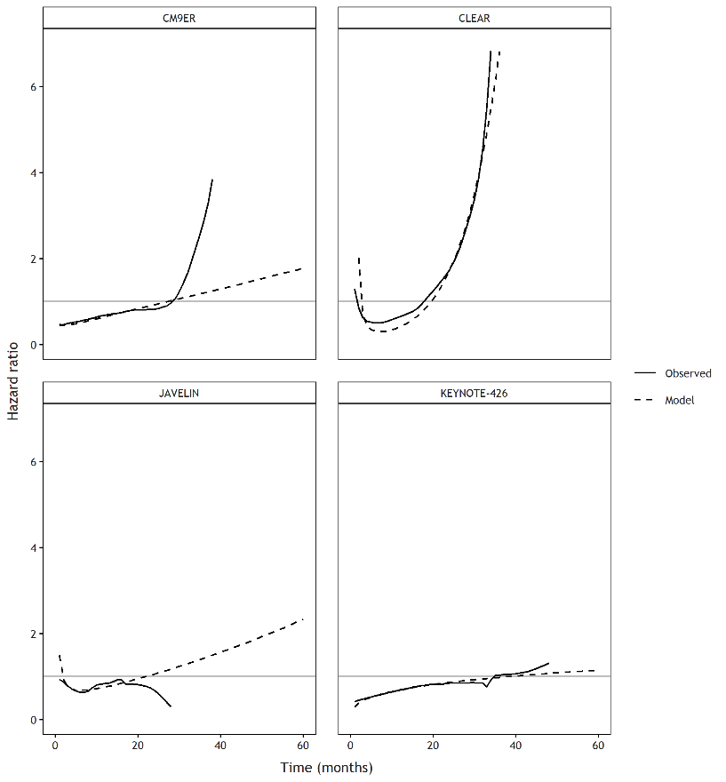
Figure 18: FP(0,0) (fixed effects).
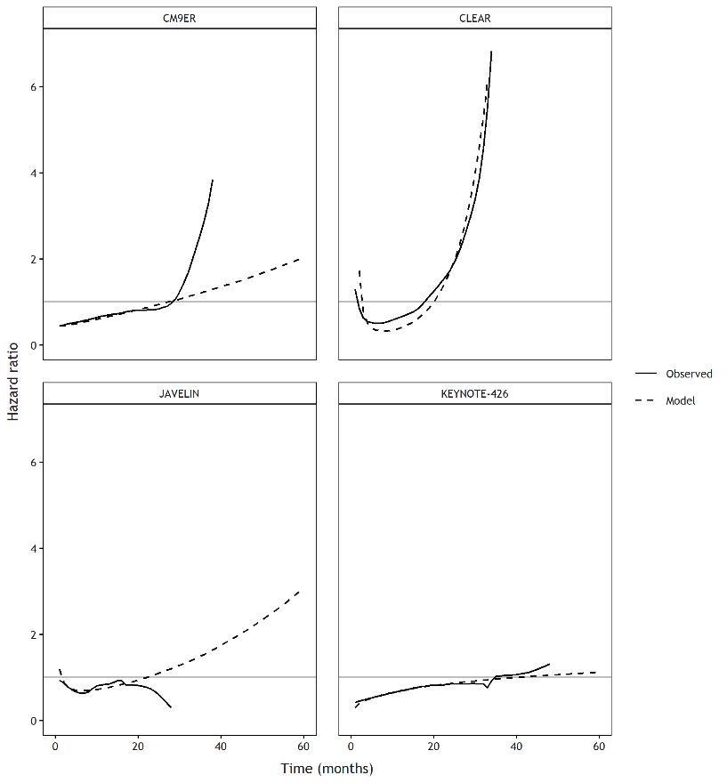
Figure 19: FP(0,0.5) (fixed effects).
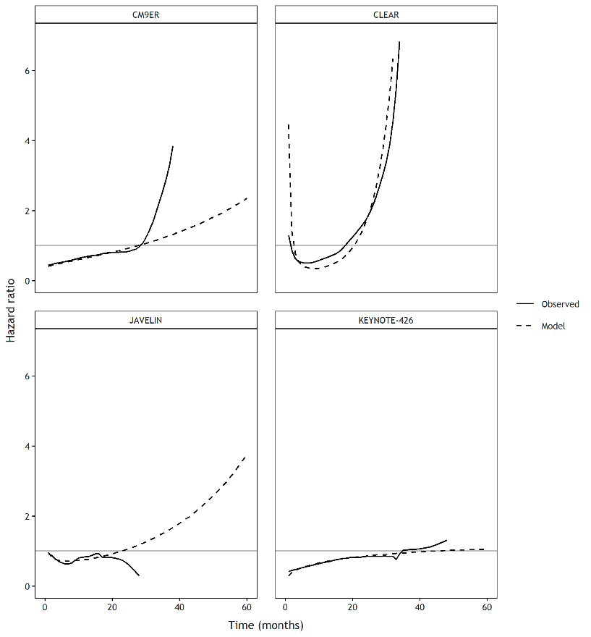
Figure 20: FP(0,1) (fixed effects).
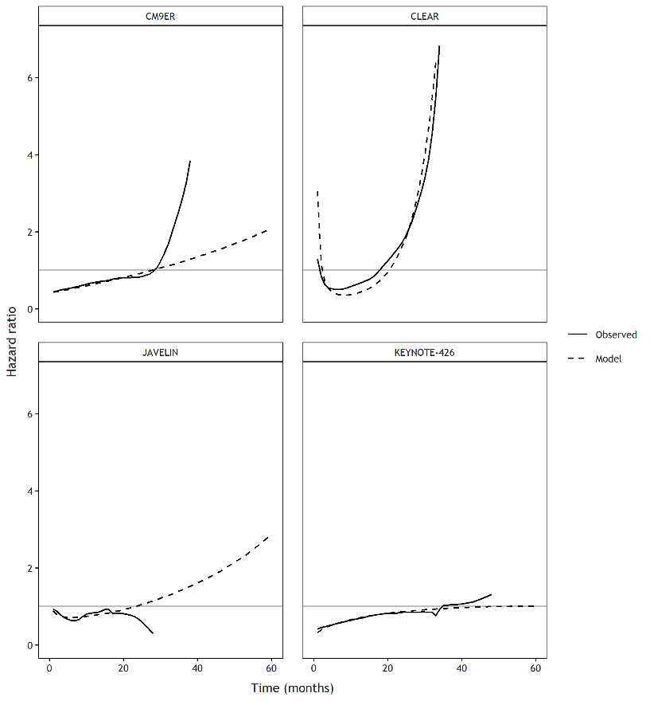
Figure 21: FP(0.5,0.5) (fixed effects).
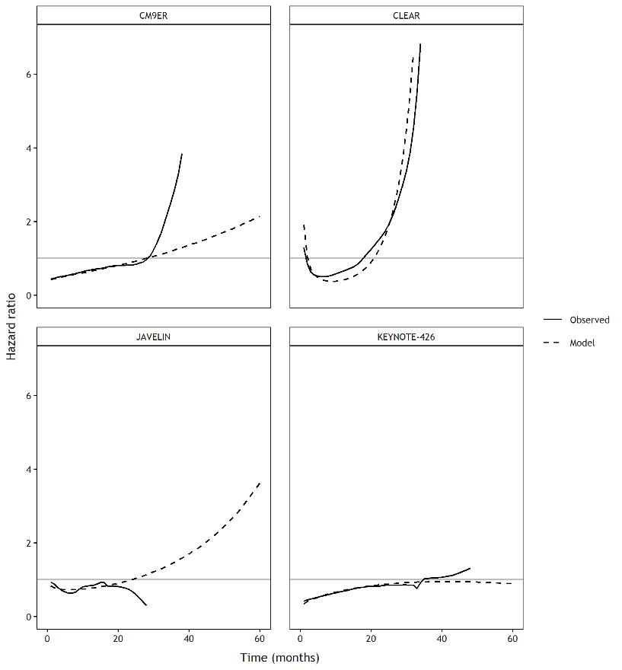
Figure 22: FP(0.5,1) (fixed effects).
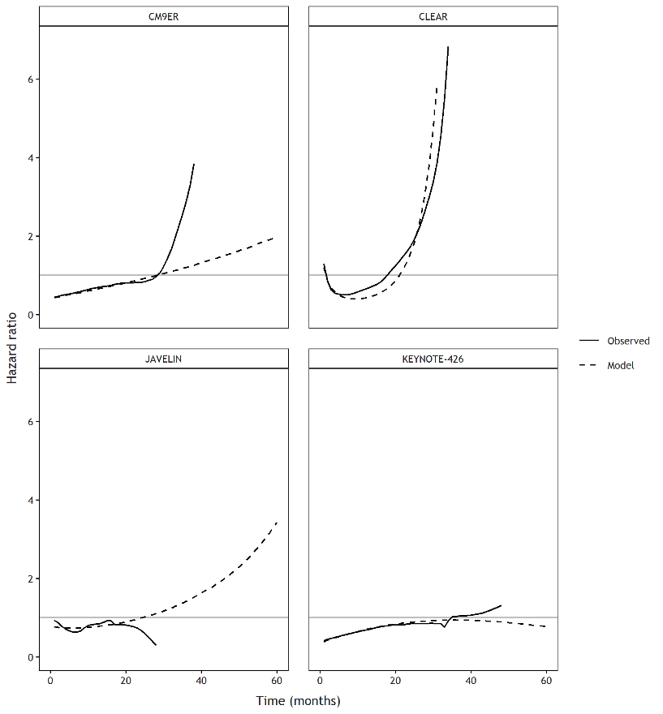
Figure 23: FP(1,1) (fixed effects).

Model selection algorithm: Predictive accuracy against trial data
Models passing the face validity check were assessed for predictive accuracy against trial data comparing observed versus predicted absolute survival at 2 years, median survival, and restricted mean survival.

PFS
Table 5. Comparison of 2-year survival outcomes between trials and NMA models
 | SUN | PEM + LEN | NIV + CAB | AVE + AXI | PEM + AXI
CLEAR | 18.1% (13.1%, 25.0%) | 46.1% (40.1%, 53.1%)
CheckMate 9ER | 19.6% (15.1%, 25.3%) |  | 38.8% (33.6%, 44.9%)
JAVELIN Renal 101 | 19.1% (13.0%, 28.1%) |  |  | 29.1% (22.3%, 37.9%)
KEYNOTE-426 | 24.3% (20.1%, 29.5%) |  |  |  | 38.3% (33.7%, 43.5%)
FP(-2) (fixed effects) | 18.57% | 49.25% | 41.50% | 31.81% | 34.94%
FP(-2,-2) (fixed effects) | 20.86% | 50.55% | 41.21% | 33.62% | 34.86%
FP(-2,-1) (fixed effects) | 21.35% | 50.41% | 40.95% | 33.88% | 35.04%
FP(-2,-0.5) (fixed effects) | 21.68% | 50.24% | 40.73% | 33.87% | 35.21%
FP(-2,0) (fixed effects) | 21.80% | 50.14% | 40.52% | 33.57% | 35.24%
FP(-2,0.5) (fixed effects) | 21.70% | 50.28% | 40.60% | 33.19% | 35.20%
FP(-2,1) (fixed effects) | 21.57% | 50.40% | 40.69% | 32.49% | 35.35%
FP(-2,2) (fixed effects) | 21.16% | 51.26% | 41.70% | 30.74% | 35.61%
FP(-1) (fixed effects) | 18.71% | 48.94% | 41.19% | 31.67% | 34.40%
FP(-1,-1) (fixed effects) | 21.70% | 50.13% | 40.37% | 33.95% | 35.09%
FP(-1,-0.5) (fixed effects) | 21.38% | 50.02% | 40.51% | 33.83% | 34.83%
FP(-1,0) (fixed effects) | 21.54% | 49.93% | 40.12% | 33.29% | 35.05%
FP(-1,0.5) (fixed effects) | 21.40% | 49.90% | 40.09% | 32.83% | 35.00%
FP(-1,1) (fixed effects) | 21.09% | 50.12% | 40.16% | 32.09% | 35.06%
FP(-1,2) (fixed effects) | 20.70% | 50.73% | 41.30% | 30.20% | 35.07%
FP(-0.5) (fixed effects) | 19.11% | 48.84% | 41.07% | 31.81% | 34.34%
FP(-0.5,-0.5) (fixed effects) | 21.49% | 50.00% | 40.00% | 33.28% | 34.94%
FP(-0.5,0) (fixed effects) | 21.26% | 49.75% | 40.03% | 32.98% | 34.79%
FP(-0.5,0.5) (fixed effects) | 21.12% | 49.86% | 39.91% | 32.41% | 34.84%
FP(-0.5,1) (fixed effects) | 20.91% | 50.06% | 40.08% | 31.84% | 34.82%
FP(-0.5,2) (fixed effects) | 20.58% | 50.51% | 41.14% | 30.27% | 34.78%
FP(0) (fixed effects) | 19.73% | 48.90% | 40.98% | 32.01% | 34.47%
FP(0,0) (fixed effects) | 21.14% | 49.74% | 39.60% | 32.59% | 34.78%
FP(0,0.5) (fixed effects) | 20.94% | 49.86% | 39.73% | 31.97% | 34.72%
FP(0,1) (fixed effects) | 20.76% | 50.04% | 40.06% | 31.45% | 34.60%
FP(0,2) (fixed effects) | 20.63% | 50.38% | 41.25% | 30.35% | 34.65%
FP(0.5) (fixed effects) | 20.35% | 49.33% | 41.09% | 32.07% | 34.73%
FP(0.5,0.5) (fixed effects) | 20.80% | 49.73% | 40.03% | 31.62% | 34.57%
FP(0.5,1) (fixed effects) | 20.73% | 49.96% | 40.45% | 31.41% | 34.46%
FP(0.5,2) (fixed effects) | 20.84% | 50.21% | 41.61% | 30.61% | 34.80%
FP(1) (fixed effects) | 20.73% | 49.94% | 40.93% | 31.88% | 34.98%
FP(1,1) (fixed effects) | 20.84% | 50.02% | 40.86% | 31.20% | 34.62%
FP(1,2) (fixed effects) | 21.11% | 50.08% | 41.88% | 30.78% | 34.87%
FP(2) (fixed effects) | 20.92% | 51.40% | 41.33% | 30.30% | 35.10%
FP(2,2) (fixed effects) | 21.61% | 50.16% | 42.40% | 31.35% | 35.14%
loglogistic (fixed effects) | 19.99% | 49.37% | 37.78% | 34.51% | 32.82%
lognormal (fixed effects) | 20.04% | 50.10% | 37.70% | 35.31% | 33.30%

Table 6. Comparison of median survival outcomes between trials and NMA models
 | SUN | PEM + LEN | NIV + CAB | AVE + AXI | PEM + AXI
CLEAR | 7.7  (5.8, 10.3) | 22.8  (19.7, 26.3)
CheckMate 9ER | 8.5  (6.9, 9.3) |  | 16.6  (13.0, 19.9)
JAVELIN Renal 101 | 7.1  (6.1, 9.6) |  |  | 12.3  (10.1, 15.1)
KEYNOTE-426 | 10.1  (8.9, 12.9) |  |  |  | 15.5  (13.9, 19.8)
FP(-2) (fixed effects) | 10.80 | 23.90 | 19.70 | 15.30 | 16.80
FP(-2,-2) (fixed effects) | 10.50 | 24.90 | 19.20 | 15.10 | 15.40
FP(-2,-1) (fixed effects) | 10.20 | 24.80 | 19.00 | 14.90 | 15.10
FP(-2,-0.5) (fixed effects) | 10.10 | 24.60 | 18.90 | 14.60 | 14.90
FP(-2,0) (fixed effects) | 10.10 | 24.50 | 18.90 | 14.50 | 14.80
FP(-2,0.5) (fixed effects) | 10.10 | 24.50 | 19.00 | 14.40 | 14.80
FP(-2,1) (fixed effects) | 10.10 | 24.60 | 19.10 | 14.40 | 15.00
FP(-2,2) (fixed effects) | 10.30 | 25.10 | 19.70 | 14.50 | 15.40
FP(-1) (fixed effects) | 10.20 | 23.70 | 19.50 | 14.80 | 16.30
FP(-1,-1) (fixed effects) | 10.00 | 24.70 | 18.70 | 14.60 | 14.70
FP(-1,-0.5) (fixed effects) | 10.10 | 24.50 | 18.70 | 14.50 | 14.70
FP(-1,0) (fixed effects) | 9.90 | 24.40 | 18.70 | 14.30 | 14.60
FP(-1,0.5) (fixed effects) | 9.90 | 24.30 | 18.80 | 14.20 | 14.70
FP(-1,1) (fixed effects) | 9.90 | 24.40 | 19.00 | 14.10 | 14.80
FP(-1,2) (fixed effects) | 10.00 | 24.70 | 19.50 | 14.20 | 15.10
FP(-0.5) (fixed effects) | 9.90 | 23.60 | 19.20 | 14.50 | 16.00
FP(-0.5,-0.5) (fixed effects) | 9.90 | 24.60 | 18.60 | 14.20 | 14.60
FP(-0.5,0) (fixed effects) | 9.90 | 24.30 | 18.60 | 14.10 | 14.60
FP(-0.5,0.5) (fixed effects) | 9.80 | 24.20 | 18.70 | 14.00 | 14.60
FP(-0.5,1) (fixed effects) | 9.70 | 24.30 | 18.80 | 14.00 | 14.60
FP(-0.5,2) (fixed effects) | 9.60 | 24.50 | 19.20 | 14.00 | 14.70
FP(0) (fixed effects) | 9.00 | 23.60 | 18.50 | 13.90 | 14.20
FP(0,0) (fixed effects) | 9.77 | 23.93 | 18.20 | 13.95 | 14.60
FP(0,0.5) (fixed effects) | 9.60 | 24.00 | 13.80 | 18.20 | 14.40
FP(0,1) (fixed effects) | 9.50 | 24.10 | 13.70 | 18.30 | 14.40
FP(0,2) (fixed effects) | 9.30 | 24.30 | 13.70 | 18.70 | 14.20
FP(0.5) (fixed effects) | 9.00 | 23.70 | 13.80 | 18.50 | 14.00
FP(0.5,0.5) (fixed effects) | 9.40 | 23.90 | 13.70 | 18.40 | 14.30
FP(0.5,1) (fixed effects) | 9.20 | 24.00 | 13.60 | 18.50 | 14.10
FP(0.5,2) (fixed effects) | 9.10 | 24.10 | 13.80 | 18.90 | 14.00
FP(1) (fixed effects) | 9.00 | 24.00 | 13.80 | 18.30 | 13.90
FP(1,1) (fixed effects) | 9.10 | 24.00 | 13.70 | 18.70 | 14.00
FP(1,2) (fixed effects) | 8.90 | 24.00 | 13.80 | 18.90 | 13.80
FP(2) (fixed effects) | 9.10 | 24.90 | 13.90 | 18.40 | 13.90
FP(2,2) (fixed effects) | 8.80 | 24.00 | 13.80 | 18.80 | 13.60
loglogistic (fixed effects) | 9.10 | 23.87 | 16.40 | 14.79 | 13.71
lognormal (fixed effects) | 9.51 | 24.45 | 16.59 | 15.50 | 14.32
NA, not available
Table 7. Comparison of restricted mean survival at 32.1 months between trials and NMA models
 | SUN | PEM + LEN | NIV + CAB | AVE + AXI | PEM + AXI
CLEAR | 10.9 | 17.2
CheckMate 9ER | 10.8 |  | 15.3
JAVELIN Renal 101 | 10.5 |  |  | 13.3
KEYNOTE-426 | 12.4 |  |  |  | 15.1
FP(-2) (fixed effects) | 12.32 | 17.89 | 16.71 | 14.93 | 15.69
FP(-2,-2) (fixed effects) | 12.46 | 17.92 | 16.45 | 14.86 | 15.05
FP(-2,-1) (fixed effects) | 12.40 | 17.95 | 16.42 | 14.80 | 14.99
FP(-2,-0.5) (fixed effects) | 12.35 | 17.96 | 16.42 | 14.74 | 14.97
FP(-2,0) (fixed effects) | 12.33 | 17.98 | 16.42 | 14.71 | 14.96
FP(-2,0.5) (fixed effects) | 12.31 | 18.02 | 16.49 | 14.68 | 14.99
FP(-2,1) (fixed effects) | 12.31 | 18.02 | 16.54 | 14.66 | 15.06
FP(-2,2) (fixed effects) | 12.31 | 18.07 | 16.71 | 14.66 | 15.23
FP(-1) (fixed effects) | 11.84 | 17.87 | 16.55 | 14.62 | 15.29
FP(-1,-1) (fixed effects) | 12.31 | 17.95 | 16.37 | 14.71 | 14.91
FP(-1,-0.5) (fixed effects) | 12.28 | 17.90 | 16.37 | 14.69 | 14.92
FP(-1,0) (fixed effects) | 12.21 | 17.91 | 16.37 | 14.61 | 14.91
FP(-1,0.5) (fixed effects) | 12.16 | 17.91 | 16.41 | 14.55 | 14.92
FP(-1,1) (fixed effects) | 12.09 | 17.93 | 16.45 | 14.49 | 14.94
FP(-1,2) (fixed effects) | 11.96 | 17.95 | 16.57 | 14.41 | 14.97
FP(-0.5) (fixed effects) | 11.64 | 17.83 | 16.34 | 14.36 | 15.01
FP(-0.5,-0.5) (fixed effects) | 12.20 | 17.91 | 16.32 | 14.58 | 14.90
FP(-0.5,0) (fixed effects) | 12.12 | 17.87 | 16.32 | 14.52 | 14.87
FP(-0.5,0.5) (fixed effects) | 12.01 | 17.86 | 16.33 | 14.44 | 14.83
FP(-0.5,1) (fixed effects) | 11.89 | 17.87 | 16.33 | 14.38 | 14.80
FP(-0.5,2) (fixed effects) | 11.67 | 17.85 | 16.39 | 14.26 | 14.72
FP(0) (fixed effects) | 11.14 | 17.73 | 15.85 | 13.94 | 14.00
FP(0,0) (fixed effects) | 11.98 | 17.82 | 16.22 | 14.40 | 14.80
FP(0,0.5) (fixed effects) | 11.81 | 17.71 | 15.95 | 14.23 | 14.69
FP(0,1) (fixed effects) | 11.63 | 17.72 | 15.87 | 14.09 | 14.56
FP(0,2) (fixed effects) | 11.39 | 17.71 | 15.86 | 13.91 | 14.32
FP(0.5) (fixed effects) | 11.20 | 17.68 | 15.77 | 13.92 | 13.97
FP(0.5,0.5) (fixed effects) | 11.59 | 17.66 | 15.89 | 14.07 | 14.48
FP(0.5,1) (fixed effects) | 11.43 | 17.65 | 15.83 | 13.97 | 14.31
FP(0.5,2) (fixed effects) | 11.29 | 17.62 | 15.80 | 13.87 | 14.14
FP(1) (fixed effects) | 11.23 | 17.66 | 15.71 | 13.94 | 14.00
FP(1,1) (fixed effects) | 11.33 | 17.62 | 15.79 | 13.89 | 14.16
FP(1,2) (fixed effects) | 11.25 | 17.56 | 15.74 | 13.85 | 14.02
FP(2) (fixed effects) | 11.31 | 17.62 | 15.74 | 13.96 | 14.09
FP(2,2) (fixed effects) | 11.22 | 17.53 | 15.66 | 13.85 | 13.93
loglogistic (fixed effects) | 11.44 | 17.81 | 15.23 | 14.62 | 14.10
lognormal (fixed effects) | 11.75 | 17.89 | 15.41 | 15.03 | 14.46

OS
Table 8. Comparison of 2-year survival outcomes between trials and NMA models
 | SUN | PEM + LEN | NIV + CAB | AVE + AXI | PEM + AXI
CLEAR | 68.8% (63.8%, 74.3%) | 77.5% (72.8%, 82.5%)
CheckMate 9ER | 60.2% (55.0%, 65.8%) |  | 70.1% (65.3%, 75.4%)
JAVELIN | 60.4% (54.1%, 67.5%) |  |  | 64.1% (57.5%, 71.4%)
KEYNOTE-426 | 65.9% (61.5%, 70.5%) |  |  |  | 74.5% (70.5%, 78.8%)
FP(-2) (fixed effects) | 58.49% | 17.06% | 70.54% | 62.83% | 69.92%
FP(-1) (fixed effects) | 59.42% | 68.67% | 70.67% | 66.26% | 70.85%
FP(-0.5) (fixed effects) | 59.56% | 70.17% | 70.85% | 66.50% | 71.32%
FP(0) (fixed effects) | 59.60% | 70.33% | 71.11% | 66.38% | 71.64%
FP(0.5) (fixed effects) | 59.58% | 70.23% | 71.44% | 66.23% | 71.65%
FP(1) (fixed effects) | 59.61% | 70.24% | 71.80% | 66.08% | 71.49%
loglogistic (fixed effects) | 59.40% | 66.67% | 70.75% | 63.60% | 67.86%
lognormal (fixed effects) | 59.49% | 68.23% | 70.27% | 64.19% | 67.70%

Table 9. Comparison of median survival outcomes between trials and NMA models
 | SUN | PEM + LEN | NIV + CAB | AVE + AXI | PEM + AXI
CLEAR | NA  (NA, NA) | NA  (32.6, NA)
CheckMate 9ER | 33.0  (29.0, NA) |  | 36.1  (35.5, NA)
JAVELIN | 26.7  (25.3, NA) |  |  | 29.5  (26.0, NA)
KEYNOTE-426 | 40.0  (35.0, 42.9) |  |  |  | 44.2  (42.7, 47.5)
FP(-2) (fixed effects) | 33.4 | 46.5 | 46.1 | 41.6 | 44.3
FP(-1) (fixed effects) | 33 | 45.3 | 45 | 40.4 | 44.4
FP(-0.5) (fixed effects) | 32.6 | 44.1 | 44.1 | 39.5 | 44.3
FP(0) (fixed effects) | 34.2 | NA | 42.7 | 42.4 | 45.6
FP(0.5) (fixed effects) | 33.1 | 37.6 | 41.7 | 39.4 | 44.8
FP(1) (fixed effects) | 33.2 | 34.6 | 40.9 | 38.3 | 44.9
loglogistic (fixed effects) | 34 | 40.6 | 45.9 | 39.5 | 42.8
lognormal (fixed effects) | 35.2 | 49.8 | 48.8 | 43 | 45

Table 10. Comparison of restricted mean survival at 32.1 months between trials and NMA models
 | SUN; | PEM + LEN | NIV + CAB | AVE + AXI | PEM + AXI
CLEAR | 23.8 | 26.1
CheckMate 9ER | 21.9 |  | 24.6
JAVELIN | 22.5 |  |  | 23.7
KEYNOTE-426 | 23.2 |  |  |  | 25.3
FP(-2) (fixed effects) | 22.65 | 24.56 | 24.71 | 24.10 | 24.67
FP(-1) (fixed effects) | 22.52 | 24.61 | 24.79 | 24.01 | 24.90
FP(-0.5) (fixed effects) | 22.37 | 24.64 | 24.83 | 23.94 | 24.95
FP(0) (fixed effects) | 21.64 | 24.61 | 24.84 | 23.31 | 24.83
FP(0.5) (fixed effects) | 21.80 | 24.78 | 24.84 | 23.41 | 24.71
FP(1) (fixed effects) | 21.90 | 24.85 | 24.86 | 23.43 | 24.61
loglogistic (fixed effects) | 21.75 | 23.80 | 24.80 | 22.74 | 24.06
lognormal (fixed effects) | 21.98 | 23.90 | 24.72 | 22.94 | 24.10

References
1. Choueiri TK, Powles T, Burotto M, et al. Nivolumab plus Cabozantinib versus Sunitinib for Advanced Renal-Cell Carcinoma. New England Journal of Medicine. 2021;384(9):829-841.
2. Motzer RJ, Penkov K, Haanen J, et al. Avelumab plus Axitinib versus Sunitinib for Advanced Renal-Cell Carcinoma. N Engl J Med. 2019 Mar 21;380(12):1103-1115.
3. Rini BI, Plimack ER, Stus V, et al. Pembrolizumab plus Axitinib versus Sunitinib for Advanced Renal-Cell Carcinoma. N Engl J Med. 2019 Mar 21;380(12):1116-1127.
4. Motzer R, Alekseev B, Rha S-Y, et al. Lenvatinib plus pembrolizumab or everolimus for advanced renal cell carcinoma. New England Journal of Medicine. 2021;384(14):1289-1300.
5. Choueiri TK, Motzer RJ, Rini BI, et al. Updated efficacy results from the JAVELIN renal 101 trial: First-line avelumab plus axitinib versus sunitinib in patients with advanced renal cell carcinoma. Annals of Oncology. 2020.
6. Rini BI, Plimack ER, Stus V, et al. Pembrolizumab (pembro) plus axitinib (axi) versus sunitinib as first-line therapy for advanced clear cell renal cell carcinoma (ccRCC): Results from 42-month follow-up of KEYNOTE-426. Journal of Clinical Oncology. 2021;39(15_suppl):4500-4500.
7. RStan: the R interface to Stan [22 December 2021]. Available from: //mc-stan.org/users/interfaces/rstan
8. Dias S, Welton NJ, Sutton AJ, et al. NICE DSU technical support document 2: a generalised linear modelling framework for pairwise and network meta-analysis of randomised controlled trials. 2011.
9. Higgins JP, Green S. Cochrane handbook for systematic reviews of interventions. Vol. 4. John Wiley & Sons; 2011.
10. Spiegelhalter D, Thomas A, Best N, et al. WinBUGS user manual. version; 2003.

